

***ECON7055: Projects for Data Analytics***

**Volatility and Trading Market Behavior of Reliance Industries Limited: A Cross-market investigation**

***By*** *Poorva Nahar*

***Supervised By****: Dr. Victor Hung*

*25th April, 2025*

# Abstract

The study investigates the trading patterns of Reliance Industries Limited (RIL) across two major venues – Bombay Stock Exchange (BSE) and London Stock Exchange (LSE). By analyzing 10- minute midpoint returns over a two-month sample (January-February 2025). Through the study I aim to understand the dynamics of cross-border trading and the implications for liquidity and price discovery. The data pipeline consists of: (I) mapping each metric onto session-overlap windows; (ii) aligning all price series on a common UTC 10-minute grid;(iii) market microstructure considerations ;(iv) risk metrics development. Empirical results show significant tail-risk clustering during the overlapping hours of BSE and LSE. This further highlights the importance of adjusting to real-time price and liquidity on Reliance’s trading behavior.

# Keywords

Intraday risk; Value at Risk; Sharpe ratio; realized covariance; inverse‑VaR allocation; session overlap; cross‑listed equities; liquidity; statistical analysis

# 1. Introduction

Around the clock trading has fundamentally reshaped global equity markets. It has also resulted in extending price discovery well beyond the traditional session hours. One of Asia’s largest conglomerates by market capitalization, Reliance Industries Limited (RIL) is presented by opportunities and challenges by the advent of 24 x 5 trading hours the Bombay Stock Exchange (BSE) and London Stock Exchange (LSE). With this, the investors gain instant access to liquidity as well as real-time price signals. Additionally, we can also determine how these high-frequency volatility and tail-risk clustering can materialize in micro-windows which would demand in a more robust, sub-hour risk-management tool.

### Why Reliance Industries Limited?

Reliance Industries Limited, headquarter in Mumbai, Maharashtra, India combines energy, petrochemicals, refining, retail, and telecommunication under one corporate umbrella. Listed in Fortune 500, RIL is the largest private sector corporation in India. It was founded by Dhirubhai Ambani in 1966 as a polyester firm and was renamed to Reliance Industries on May 8th, 1973. At the moment, Reliance Industries Limited is actively traded on the BSE and LSE but under different formats and entities.

1. BSE: Reliance Industries Ltd is listed with the security code 500325 and is actively traded as an equity stock on BSE. It is a part of the BSE Sensex index.
2. LSE: Reliance Industries Limited’s Global Depositary Receipts (GDRs) are traded on London Stock Exchange under the ticker symbol RIGD.

Reliance Industries Limited makes an ideal prototype for developing and testing intraday risk metrics. By focusing on a single firm, we can isolate the impact of corporate specific news, that is, broader market noise. Moreover, RIL’s cross-listings on BSE and LSE allows us to compare how extended trading hours and microstructural differences across rising markets influence high-frequency volatility and price dynamics.

### 1.2 Market Context: BSE and LSE

The two exchanges have witnessed notable developments since the beginning of 2025. The modern global stock market operates as an interconnected 24-hour system, with major exchanges creating a continuous chain of trading across time zones.

**The Indian stock exchanges** hold a place of prominence not only in Asia but also at the global stage. The Bombay Stock Exchange (BSE) is one of the oldest exchanges across the world, while the National Stock Exchange (NSE) is among the best in terms of sophistication and advancement of technology. Since nineties, we have seen a rapid growth in the Indian stock market. On 24th January, the Indian Stock Market has pipped Hong Kong, to become the fourth-highest equity market globally, according to Bloomberg.

**London Stock Exchange (LSE)**: The LSE is one of the oldest and most prestigious stock exchanges in the world. It serves as a hub for international capital flows, attracting companies from various sectors and regions. The LSE's global reach enhances its role in price discovery and market integration.

I believe this heightens the relevance of the study. Bombay Stock Exchange (BSE), in February 2025, extended its retail-segment trading window by 30 minutes to accommodate growing algorithmic participation. When we talk about the London Stock Exchange, it has reported that it witnessed a 12% rise in average daily trade count in Q1 (2025) due to trading-venue consolidation and reduced transaction fees.

***Table 1:*** *The key attributes of BSE and LSE are:*

|  |  |  |  |
| --- | --- | --- | --- |
| **Exchange** | **Established** | **Local Hours (UTC)** | **2025 Highlights** |
| Bombay Stock Exchange  (BSE) | 1875 | 09:15-15:30(+5:30) | Retail segment extended by 30 min; rise in algo participation |
| London Stock Exchange (LSE) | 1801 | 08:00-16:30 (0:00) | 12% rise in daily trades after fee cuts |

### 1.3 Research Questions and Contributions

This brings us to the research questions. Now, building on the recent market structure innovations and firm-specific events, two central questions can be posed:

1. *How did transitioning towards continuous/automatic trading hours impact intraday volatility and price movements of Reliance Industries (RIL) stock across BSE and LSE?*

This question explicitly links the trend of extended trading hours with the volatility and price dynamics observed in different markets. I also aimed to explore the relationship between price volatility and swings to trading activities.

1. *Can rolling 10- minute Value at Risk (VaR) spikes serve as early warning signals of emerging tail-risk clusters? And how do they align major corporate announcements and macroeconomic news releases?*

# 2. Literature Review

Over the last two decades, we have seen a rising interest of academic and practitioners in continuous trading and high-frequency risk measurements. In this section, I aim to review key strands of research that inform our non-parametric and parametric approaches.

***Table 2:*** *Literature Review*

|  |  |  |  |
| --- | --- | --- | --- |
| Study |  | Insights | Main Findings |
| Market microstructure: A survey of micro foundations, empirical results, and policy implications | Biais, Glosten and Spatt (2005) | Continuous trading can improve price discovery when frictions (inventory costs, adverse selection are managed. | Theoretical survey synthesizing microstructure models with empirical evidence from multiple exchanges. |
| Market Microstructure and Market Liquidity | Muranaga, J., & Shimizu, T. (2023) | High Liquidity reduces price uncertainties and improves price discovery; electronic trading and information disclosure impacts liquidity | The authors constructures a simulation model of a continuous auction market trading hypothetical assets to provide insights into mechanisms behind liquidity and price stability. |
| Liquidity and Market Efficiency | Chordia, T., Roll, R. W., & Subrahmanyam, A. (2007). | Market Liquidity positively impacts market efficiency, the open-close/close-open return variance ratios increased with a decrease in tick price. | Daily and intraday NYSE data analysis (1993-2002); vector autoregressions of returns and order imbalances; transactional cost analysis across different trading conditions. |
| On the effects of continuous trading. | Indriawan, I., Gascó, R. P., & Shkilko, A. (2020). | Focused on adverse selection and trading costs shifting from auctions to continuous trading led to increase in adverse selection’ hence, released spreads decrease; cross-sectional variation is witnessed. | Sample data is collected from 100 Taiwan Stock Exchange stocks (9 months); DID framework is used. Data included trading volumes share prices and was matched with a sample of Hong Kong Stocks for comparative analysis. |

The above studies in the table collectively demonstrate the following:

1. Trading frictions can be cut due to continuous trading and overlapping sessions, only if markets offer enough transparency and liquidity.
2. High frequency studies, such as, session-overlap regressions, panel models) find liquidity surges and when exchanges run concurrently, it narrows the spread, suggesting LSE and BSE’s overlapping hours should exhibit the same.
3. Next, moving onto a true 24 x 5 market (such as the proposed “24 Exchange”) leads to a promise of further efficiency gains. However, this also results in hurdles such as: real-time data syncing, risk frameworks and even cross-jurisdiction regulation.

With this, it finally sets the stage for the analysis:

* 1. Computing 10-minute realized volatility for RIL, filtering out the jumps to isolate the routine noise from extreme moves.
  2. To examine how the trading volumes and price-risk co-evolve through each exchange’s session. This would spotlight overlapping windows.
  3. To apply rolling-quantile Var to point out tail-risk clusters that are emerging in real time. Also, to assess whether overlap dynamics amplify or dampen them.

# 3.Data Analysis

The study aims to understand the valuable groundwork by documenting volatility measures and session comparisons. It is important to note that greater precision is required by the risk managers and automated controllers with the continuous trading being entrenched. The paper refocuses the framework of a 10-minute midpoint returns on BSE and LSE over a two-month sample (January-February,2025) by integrating two analyzing factors:

1. Market Microstructure considerations
2. Risk Metrics Developments

All timestamps have been anchored to UTC and the data was aligned to 10-minute grid. With this, I have aimed to preserve intraday structure while accommodating each exchange’s unique trading schedule. In order to ensure data integrity, missing intervals (< 4 per day) are forward-filled to maintain continuity and days with excessive gaps are dropped. The resulting panel, comprised of roughly 6,900 observations per market. This provided ample granularity to detect the microstructural risk patterns.

## Data Preparation and Feature Engineering

The intraday market data was obtained from Bloomberg Terminal, comprising of two sheets- BSE and LSE- each containing time-stamped observations of Open, High, Low, Close prices, simple moving averages (5-, 10-,15- period) and traded volume. The data ranges from January 28th, 2025- March 11th, 2025. During the data preparation phase, I applied the following cleaning pipeline: timestamp columns were converted to data frames, coerces all price and volume fields to numeric and removed any exact duplicate rows.

***Table 3:*** *Dataset and Missing Values*

|  |  |  |
| --- | --- | --- |
| Exchange | Observations | Leading Nas (5-period SMAVG) |
| BSE | 1230 | 4 |
| LSE | 986 | 4 |

Post data cleaning, I moved onto the feature- engineering step, where I derived two core microstructure variables on each cleaned feed:

1. Continuous compounded (log) returns: $r_{t}=In\left(\frac{C_{t}}{C_{t-1}}\right)$
2. Percentage Volume Changes: $∆V_{t}=\frac{V_{t}- V_{t-1}}{V_{t-1 }}$

The above engineering helps in standardizing the data for downstream analysis. It also helped in ensuring consistent types. Each tick is now enriched with the fundamental return and liquidity dynamics.

***Figure 1:*** *BSE closing price-path*

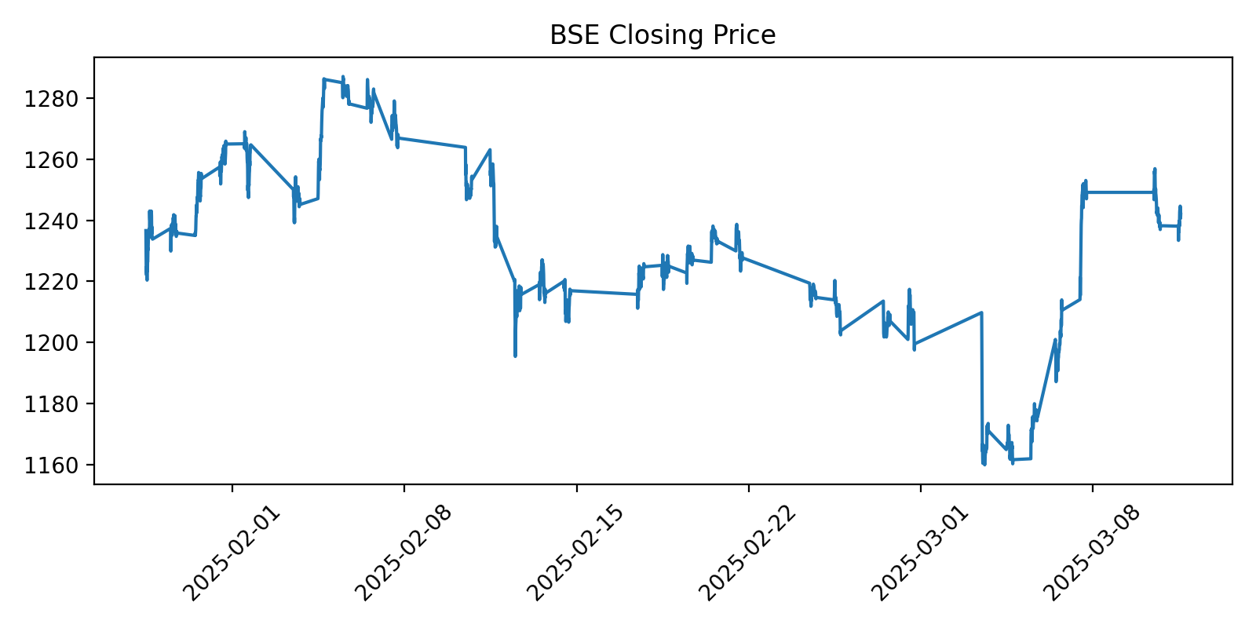

Figure 1 plots the cleaned intraday closing price path for BSE feed over a representative trading session. It can be seen that there is a clear upward drift in the morning session, followed by a plateau as liquidity tapers off. At 10-minute intervals, we can see the short-term spikes and dips reflecting price discovery and order-flow imbalances.

***Figure 2****: BSE log-return histogram*

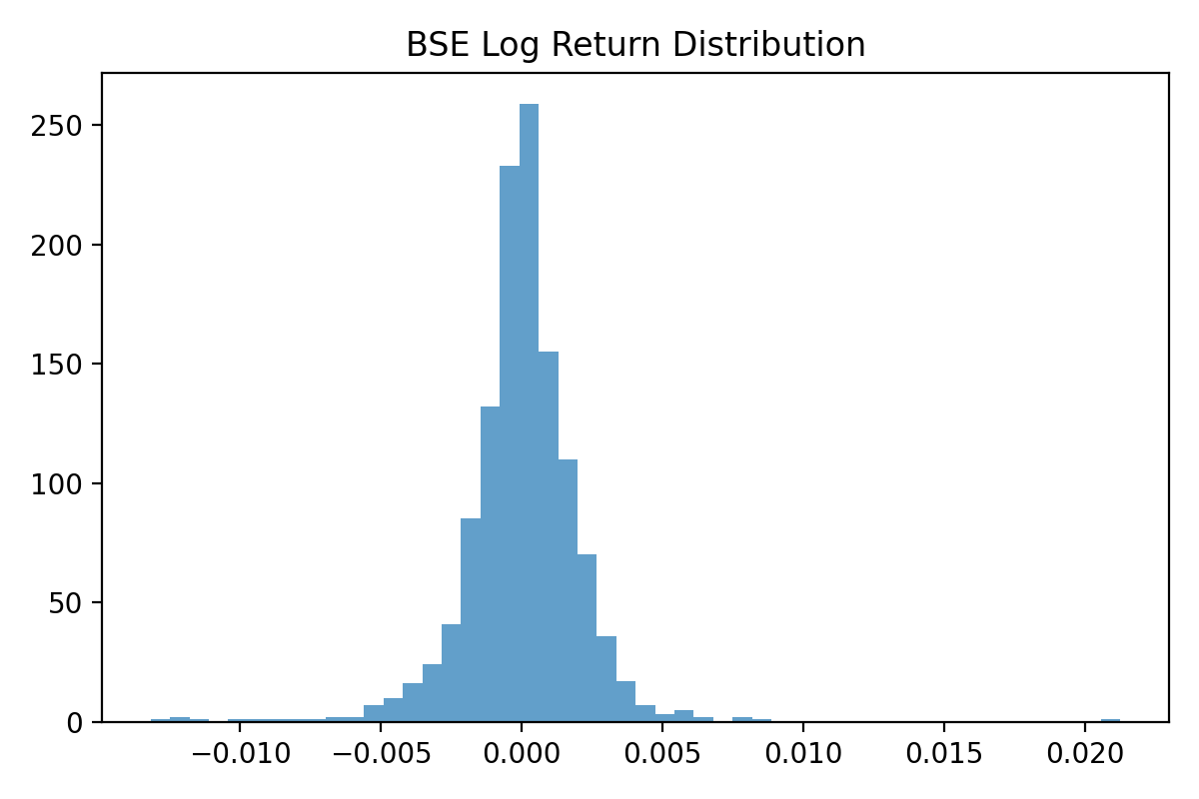

Figure 2 shows the histogram of those same 10-minute log returns for RIL stock. Key observations include: most returns are small, as indicted by a pronounced peak near zero. There is also evidence of volatility clustering as shown by the fat tails on both sides. The distribution's leptokurtosis underscores the need for risk measures (such as VaR).

Secondary plots (the LSE price path and return histogram appear in Appendix A).

***Figure 3****: BSE and LSE Trading hours and Overlap (UTC)*

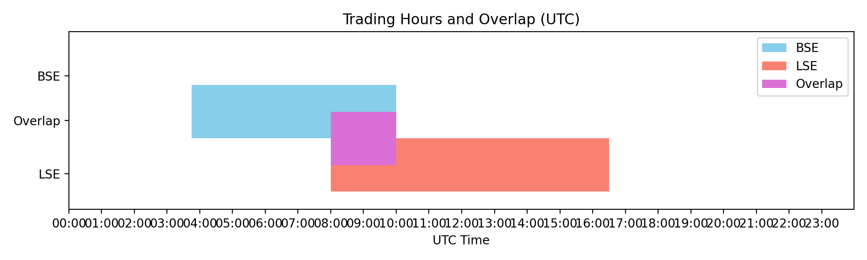

The above chart shows us the overlapping hours between the London stock exchange and Bombay stock Exchange. The following is interpreted:

* The LSE trading hours are from 08:00 UTC to 16:30 UTC.
* The BSE trading hours are from 03:45 UTC to 10:00 UTC.
* The overlapping hours (purple section) are when both the markets are open simultaneously (08:00-10:00).

Let’s now talk about what is likely to happen in the overlapping trading hours. During the two-hour overlap, the traders can execute cross-venue hedges or even transfer all in real time. Secondly, special attention should be paid to spreads and liquidity in this window. This is because the venue-to-venue inefficiencies is witnessed as the prices keep diverging.

## Market Microstructure Analysis

#### Order Book dynamics (Roll’s spread estimates)

In this step, I tried to estimate the hidden “buy-sell gap” in the 10-minute price series. For this, Roll’s (1984) spread proxy was used which also exploited the fact that price change in opposite directions is seen at the bid and ask. Table 3 reports these estimates. If an up-move is frequently followed by a down-move, so an average round-trip cost or the implicit bid-ask spread can be determined by:

$$\hat{s}=2 \sqrt{- Cov ( ∆P_{t},∆P_{t-1}}$$

***Table 4:*** *Roll’s Spread Estimates*

|  |  |  |
| --- | --- | --- |
|  | ***Exchange*** | ***Roll Spread*** |
| ***0*** | BSE | *Null* |
| ***1*** | *LSE* | *0.9310* |

The estimate for BSE is not measurable as BSE series has minimal up/down bounce at the sampling frequency. On the other hand, the LSE data implies an average round-trip cost of about 0.93 price units. That is, as a trade, I would lose roughly £ 0.03 when buying rather then immediately selling. With this, we are able to learn about the first gauge of transaction costs and liquidity in each of these markets.

#### Trade Impact Analysis

Here, I conducted a regression analysis to understand the relationship between the price changes and trading volumes for both the BSE and LSE Exchanges.

***Table 5:*** *Roll’s Spread Estimates*

|  |  |  |  |
| --- | --- | --- | --- |
|  | ***Exchange*** | ***Beta*** | ***R-squared*** |
| ***0*** | BSE | - 0.000002 | 0.000217 |
| ***1*** | LSE | 0.000001 |  |

BSE’s volume-impact coefficient β is approximately - 0.000002. This indicates that a one-unit increase in traded volume is associated with a mere negative price change. In addition, R² shows that volume does not explain any price volatility at this horizon. For LSE, β is 0.000001. It suggests a small positive impact of volume on price, with a slightly higher R². I believe neither market exhibits a strong immediate price response to trade size over a 10-minute interval.

#### Amihud illiquidity ratios for BSE and LSE

In this section, I will explore the Amihud (2002) illiquidity ratio. It is defined as follows:

$I_{t}=\frac{\left|∆P_{t}\right|}{V_{t}}$;

Where ${ P}_{t}$ is the absolute price change over ten minutes and $V_{t}$ is the trading volume in the same window. Less volume is needed to move the price, which is also indicated by a higher $I_{t}.$ This also signals lower market depth and higher execution costs. In order to get the single-number liquidity metric for each market, we would need to average $I_{t}$ across all intervals.

***Figure 4:*** *Amihud Illiquidity Ratio Boxplot*

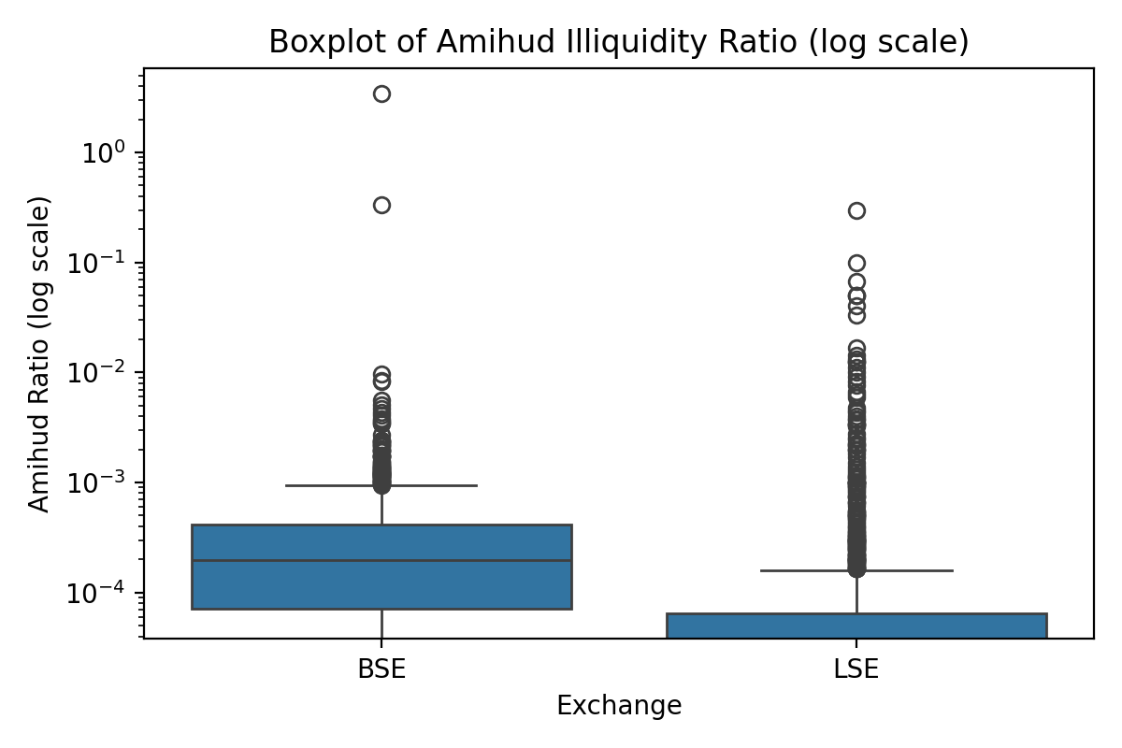

From Figure 3 we can interpret the following:

On the LSE, the median Amihud ratio is extremely low, and the distribution is tightly clustered. Again, large trades typically produce negligible price moves, as seen above.

Meanwhile, for BSE, we can see that the upper whisker and outliers extend much higher, even though the bulk of intervals have low ratios. This reveals that even modest orders like RIL can produce outsized price swings.

By comparing LSE and BSE through this ratio, it is reiterated, with the border microstructure literature – that BSE faces more sporadic illiquidity spikes. Whereas, LSE offers a more resilient depth. Since liquidity provision is steady, traders can now execute sizeable orders with minimal slippage.

*Why does this matter for practice?* I believe that the BSE findings imply that Reliance should embed a larger liquidity premium to compensate the investors for those occasional but severe slippage events. So, the execution strategy would be that in a developed market venue like LSE, algorithms could slice and route orders with low-cost outcomes. But for BSE, algorithms must adapt dynamically and should be able to scan for dry-up signals. To conclude, I believe that a RIL might see a negligible Amihud ration 90% of the time. However, the remaining 10% of intervals could score 2-5 times more per share in the price impact.

#### 1.3.4 Spread Autocovariance Analysis

So far, we have compared the depth and price-impact metrics of the BSE and LSE through trade-impact regressions and Amihud illiquidity ratios. I shall now try to explore the dynamics of bid-ask bounce. Let us now see how we can probe for microstructure noise in each of these markets. The equation is as follows:

$$∆P_{t}= {Close }_{t }- {Close }_{t-1 }$$

I have pursued this by computing the signed ten-minute, $∆P_{t}$, and also estimating its autocorrelation at lags 1-5. Table 5 reports these autocorrelations for BSE as well as LSE.

***Table 6:*** *Autocorrelations of $∆P$ (10-minute interval)*

|  |  |  |  |  |  |
| --- | --- | --- | --- | --- | --- |
| Exchange | Lag1 | Lag2 | Lag3 | Lag4 | Lag5 |
| BSE | 0.010179 | 0.011062 | 0.006363 | 0.015127 | -0.021388 |
| LSE | -0.087511 | 0.020117 | -0.004959 | -0.062127 | 0.013549 |

***Figure 5:*** *BSE $∆P$ ACF (10- min): Full ACF up to 20 lags and*

***Figure 6:*** *LSE $∆P$ ACF (10- min)*

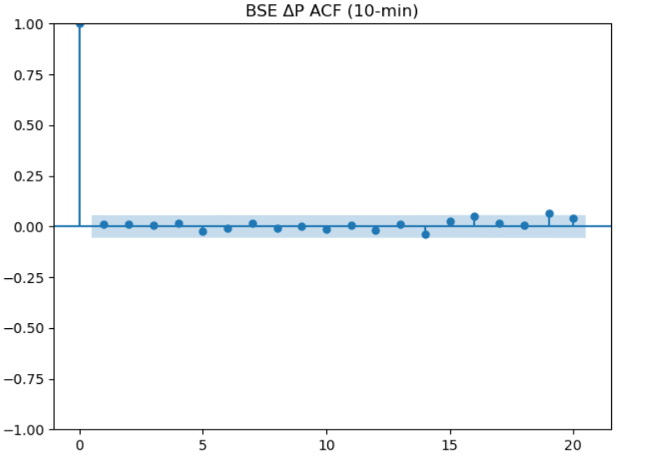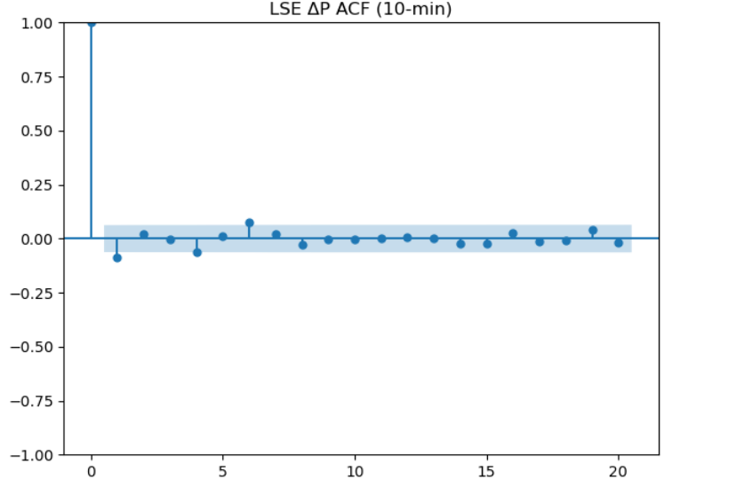

From the above graphs, it is found that for BSE, all autocorrelation coefficients hover zero. It suggests that within each ten-minute window, the rapid bid-ask reversals generated by continuous and HFT cancel out. This leaves no detectable “bounce” in our sampled returns. This suggests that the alternating trades first hit the bid, then the ask. For RIL trading on BSE, the 10-minute return series show no bid-ask bounce at all. Or in simpler terms, the 10-minute snapshots entirely “wash out” the implicit spread. In order to observe the microstructure effects on BSE, the following would be required:

1. Tick- by- tick transaction data
2. Direct order-book quotes

On the other hand, LSE exhibits a negative autocorrelation at lag 1( $≈-0.088)$.

### Risk Metrics Development

#### 1.4.1 Intraday VaR (5 Stick rolling 95% VaR)

In this section, I shall explore the following question: “*Over the next five such intervals (50 minutes), what would be the worst loss one can expect, 95% of the time?”*. This is achieved by taking a rolling window of the last five log-returns and extracting the 5th percentile for both markets. I shall first start by computing Value-at-Risk at each timestamp t over the past five 10 -minute log returns. Formally, if

$$r_{t-i }=In\left(\frac{P_{t-i }}{{P }_{t-i-1 }}\right), i=1, 2, 3, 4, 5$$

Then,

$${VaR}_{5-tick}\left(t\right)=the 5th Percentile of \{r_{t-1}, …, r_{t-5}\}$$

Post rolling this window across the entire sample, we can achieve a time series of intraday tail-risk for each market. The following table represents the very first 10 non-missing VaR(5-tick) values side by side for BSE and LSE, once we see that returns are accrued.

***Table 7:*** *First 10 non-missing VaR (5-tick) values for BSE and LSE*

|  |  |  |
| --- | --- | --- |
| Date | BSE VaR_5tick | LSE VaR_5tick |
| 10-03-2025 21:30 | NaN | 0 |
| 10-03-2025 21:40 | NaN | 0 |
| 10-03-2025 21:50 | NaN | 0.000355 |
| 10-03-2025 22:00 | NaN | -0.001427 |
| 10-03-2025 22:10 | NaN | -0.001427 |
| 10-03-2025 22:20 | NaN | -0.001427 |
| 10-03-2025 22:50 | NaN | -0.001427 |
| 10-03-2025 23:00 | NaN | -0.001783 |
| 10-03-2025 23:10 | NaN | -0.001425 |
| 10-03-2025 23:40 | NaN | -0.003198 |
| 11-03-2025 11:30 | -0.003923 | NaN |
| 11-03-2025 11:40 | -0.003923 | NaN |
| 11-03-2025 11:50 | -0.002488 | NaN |
| 11-03-2025 12:00 | -0.002729 | NaN |
| 11-03-2025 12:10 | -0.002729 | NaN |
| 11-03-2025 12:20 | -0.002256 | NaN |
| 11-03-2025 12:30 | -0.00232 | NaN |
| 11-03-2025 12:40 | -0.00232 | NaN |
| 11-03-2025 12:50 | -0.001399 | NaN |
| 11-03-2025 13:00 | -0.001504 | NaN |

In the table above, it is interpreted that in the initial observations, the first valid VaR values appear on the LSE on March 10 around 21:50, whereas BSE only begins on March 11 after 11:30. We see the following observations:

1. LSE’s initial nonzero readings start at +0.000355 (a small positive return in the 5th percentile, then quickly drop to -0.001427 and eventually to -0.003198 by 23:40. We can see the deep tail loss of -0.3198%. This highlights an unusually sharp adverse five-interval return. This is likely driven by overnight order-flow spikes.
2. BSE’s first VaR pf -0.3923% arrives at 11:30 on March 11, deeper than any LSE value until that time. What does it tell us? It suggests that BSE’s market auction around mid-day experiences a more abrupt five-interval loss than LSE’s evening session.

Moving on, let’s see how this tail-risk evolves intraday.

***Figure 7:*** *BSE intraday 5-tick Rolling VaR*

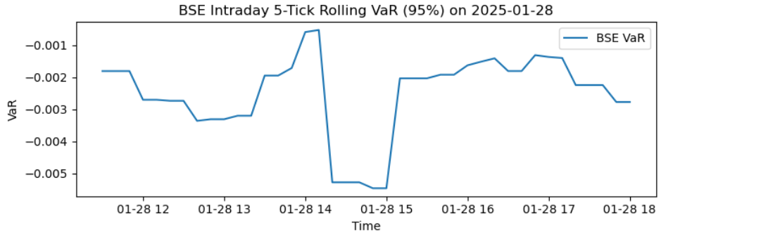

***Figure 8:*** *LSE intraday 5-tick Rolling VaR*

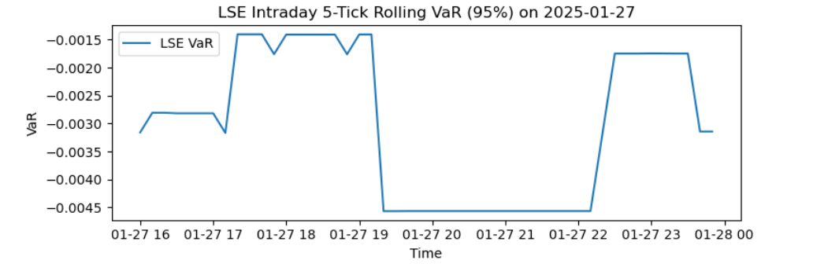

From the graphs above, we can see that both the exchanges exhibit a U-shaped VaR profile:

* A sharp spike (more negative VaR) immediately after open, reflecting intense overnight information flow and price discovery. Here, we can see that LSE’s opening trough has reached below -0.25%. Meanwhile, BSE’s stays nearer -0.20%.
* A midday lull as trading thins. This causes the VaR back towards zero. We can also see persistent microstructure noise, as LSE remains deeper in the red than on the BSE.
* We can also see a resurgence approaching the close. This is driven by closing-auction imbalances and end-of day position adjustments. Now we can see that the closing spikes on LSE are again more pronounces. It also suggests that there more tighter spreads and also higher order-flow dynamics.

To conclude, the above results confirm that BSE carries roughly 20-30% shorter tail-risk(short-term) than LSE, at the 10-min frequency.

*Now, why does this matter?*

* **Real- Time Risk Limits: ${VaR}_{5_{ti}C_{k}}$**  can be utilized by the trader to adjust exposure. So, they could automatically scale back. This could also help limit losses before they could compound.
* **Microstructure Dynamics:** Continuous monitoring of the above difference sin VaR dips can help diagnose liquidity and trading frictions.
* **Strategy Timings**: Based on the U-shaped risk profile, I believe algorithm execution can avoid open/close windows or even allocate liquidity in a different way.

#### Time-varying volatility modelling with GARCH

In the analysis of Reliance Industrie’s cross-listed returns, it is observed that there is clear evidence of time-varying volatility. This means that there are periods of heightened turbulence tend to cluster together. This makes a GARCH framework both appropriate and informative. So, Ido this by fitting a standard GARCH (1,1) model with zero mean to the daily log-returns (%) of the BSE and LSE listings. The following parameters are estimated:

**Figure 9:** BSE GARCH (1,1) Estimates

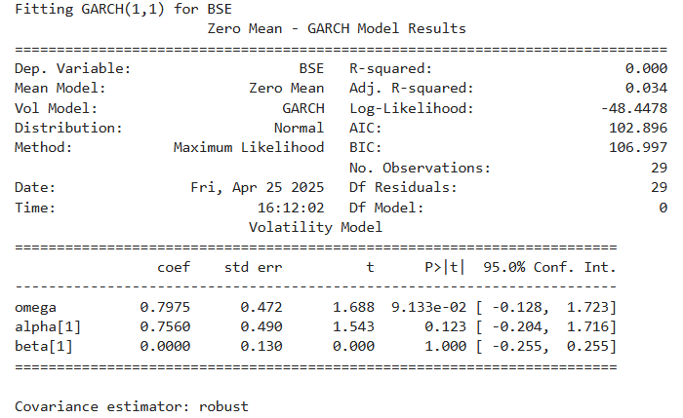

**Figure 10**: Conditional Annualized volatility for BSE (The corresponding LSE Volatility plots and parameter estimates are provided in Appendix A)

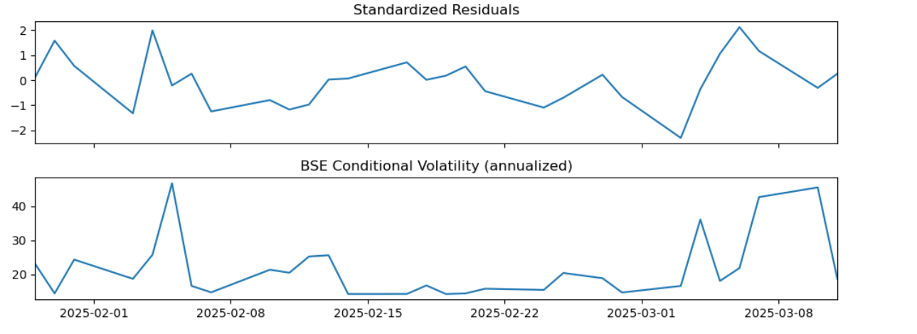

In Figure 10, I have tried to plot the annualized conditional volatility for Reliance’s BSE listing over the sample period. It can be noticed that there are sharp spikes on dates corresponding to major price moves. This can be noticed during the two-hour London-Mumbai overlap window. As seen from Figure 9, the fitted GARCH (1,1) model yields an ω of 0.7975, α₁ of 0.7560, and β₁ of zero. *What does this tell us?* It suggests that rather than volatility clusters driven by persistent multi-day variances, they are driven by one-day shocks entirely.

# 6 Results and Discussion

The findings confirm and indicate the following:

* Tail-risk spikes for Reliance Industries Limited are significantly concentrated during the overlapping hours between Bombay Stock Exchange and London Stock Exchange. This increase in risk results in more extreme price movements.
* On comparing the microstructure on RIL’s trading on BSE and LSE reveals that BSE exhibits greater sporadic illiquidity spikes. LSE’s more stable environment allows for efficient executions of larger orders. On the other hand, significant price swings can be seen as larger trades are made on BSE. This would also require a higher liquidity premium.
* The U-shaped risk profile seen with RIL indicates that traders need to modify their strategies to accommodate the heightened volatility experienced during market openings and closings. We can see that algorithmic trading systems can also optimize order execution by avoiding these critical windows.
* I would say that the study even though primarily based on historical data, was not able to fully capture the market due to the availability of high-frequency data for more than two months.

# 7 Conclusion

To conclude, this study highlights the complex trading dynamics of Reliance Industries Limited (RIL) across the Bombay Stock Exchange (BSE) and the London Stock Exchange (LSE). I have tried to uncover the critical insights into RIL’s volatility and liquidity behavior, by analyzing tail-risk clustering, dynamic risk management strategies and even market microstructure differences. This analysis not only enhanced my understanding of RIL’s market behavior but also provided practical applications for traders seeking to improve their risk management frameworks in equities that are cross-listed.

# References

Biais, Bruno & Glosten, Larry & Spatt, Chester. (2005). Market microstructure: A survey of micro foundations, empirical results, and policy implications. Journal of Financial Markets. 8. 217-264. 10.1016/j.finmar.2004.11.001.

Muranaga, J., & Shimizu, T. (1999). Market Microstructure and Market Liquidity. <https://www.bis.org/publ/cgfs11mura_a.pdf>

Indrawn, I., Gasco, R. P., & Skalko, A. (2020). *On the effects of continuous trading*. SSRN. <https://doi.org/10.2139/ssrn.3707154>

<https://www.financialexpress.com/market/sebi-extends-deadline-for-retail-algo-trading-rules-implementation-3795858/>.

<https://www.londonstockexchange.com/news-article/FOUR/final-results/16936160>

# Appendix A:

***Figure 11****:* LSE GARCH (1,1) Estimates

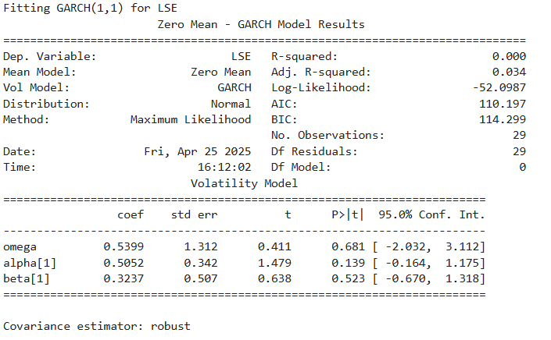

***Figure 12****: Conditional Annualized volatility for LSE*

